Python Project EDA & Data Viz - Airbnb Listing 2024 (New York)

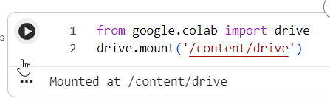
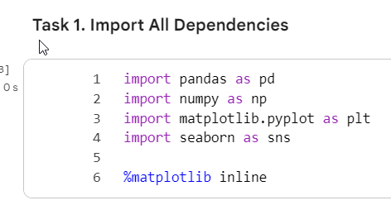

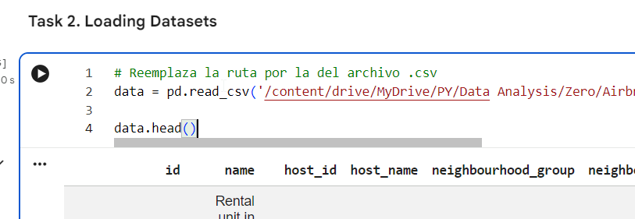

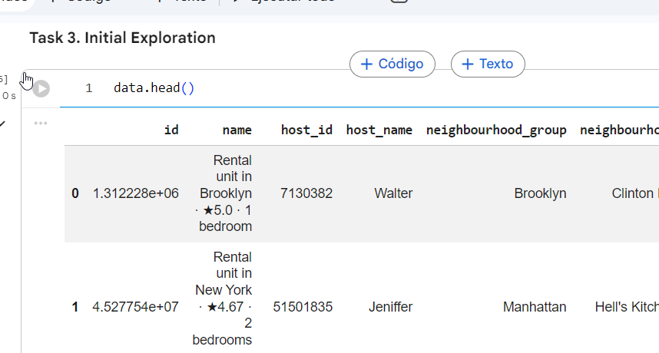

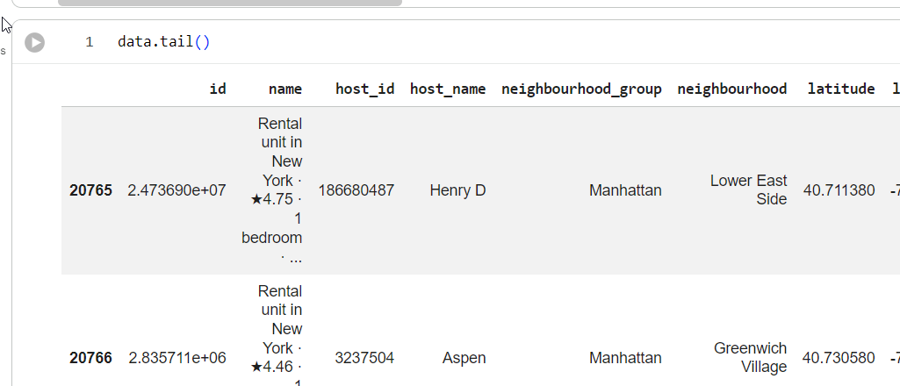
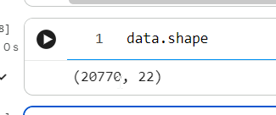
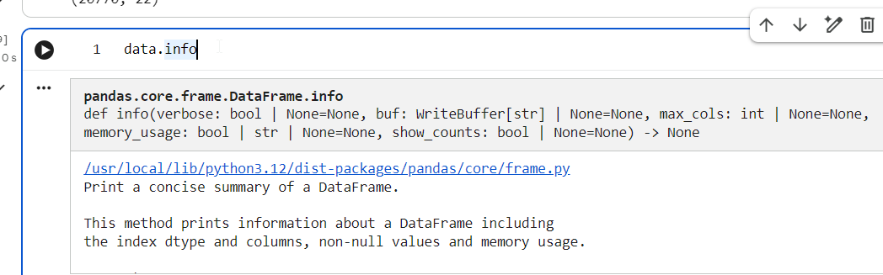
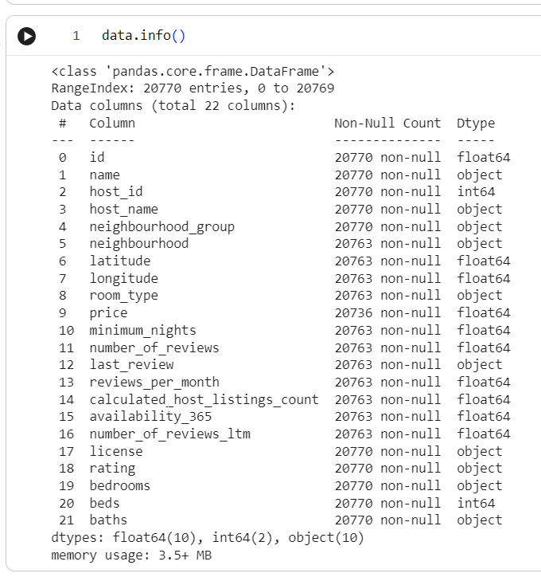
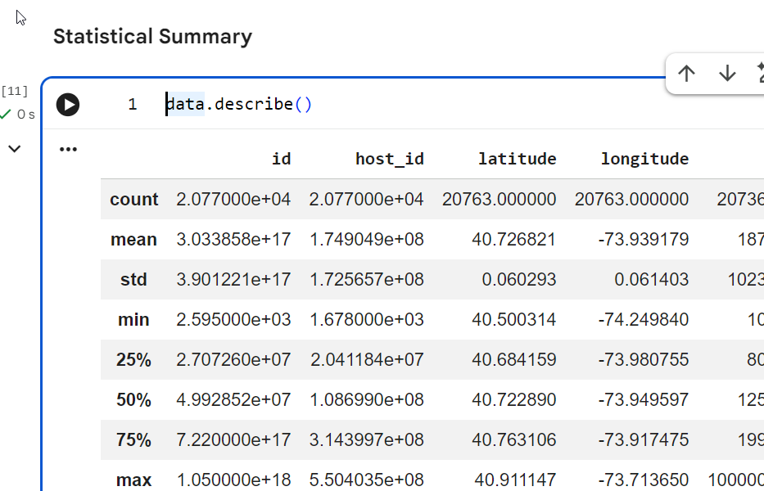
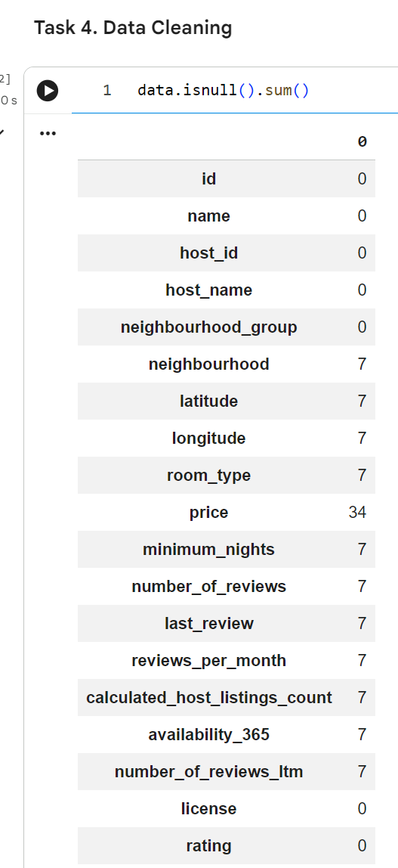

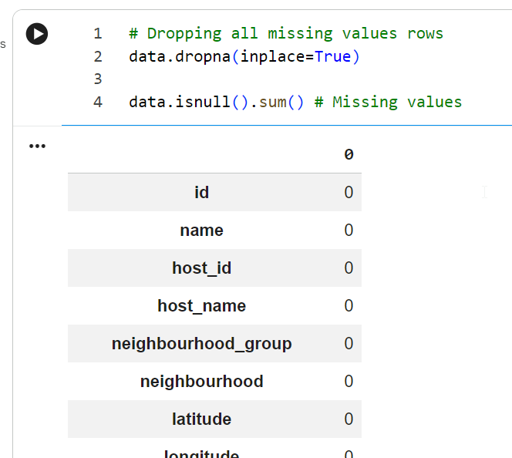

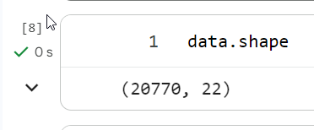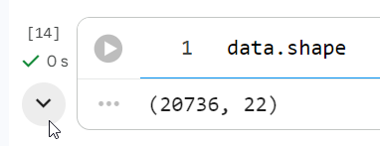
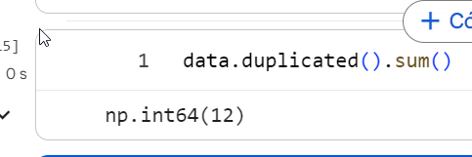

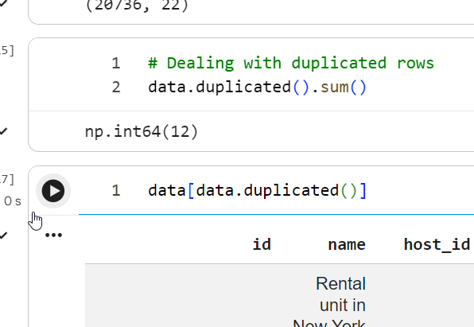

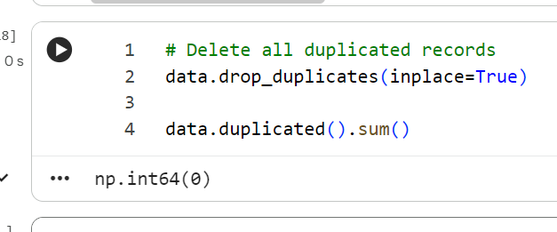

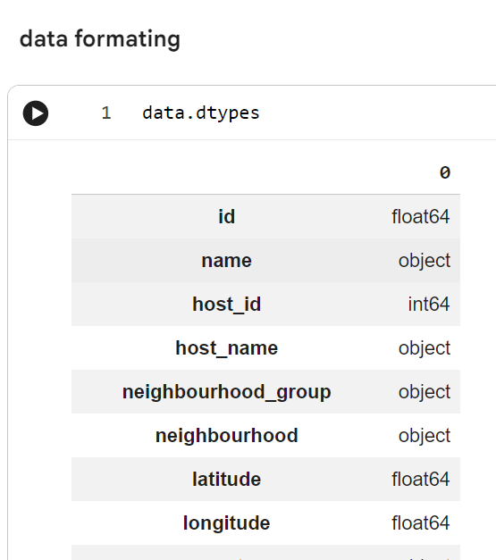

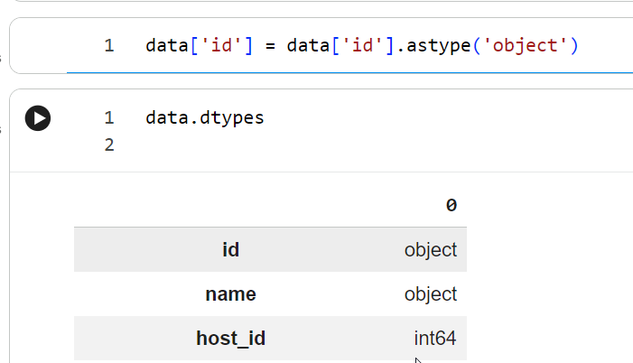

Converted the id column to a string (object) data type to treat it as a categorical identifier rather than a numerical value. This prevents Pandas from performing unintended mathematical calculations on unique IDs. Verified the updated data types using data.dtypes.

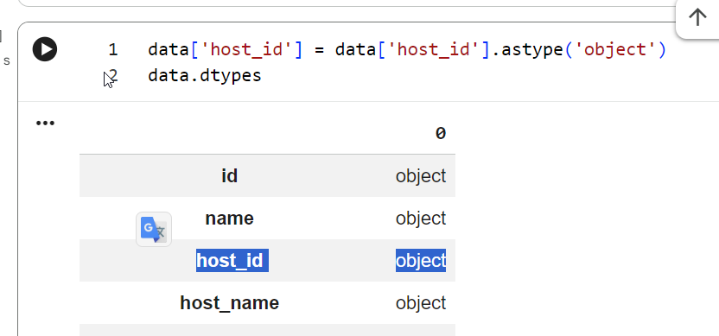

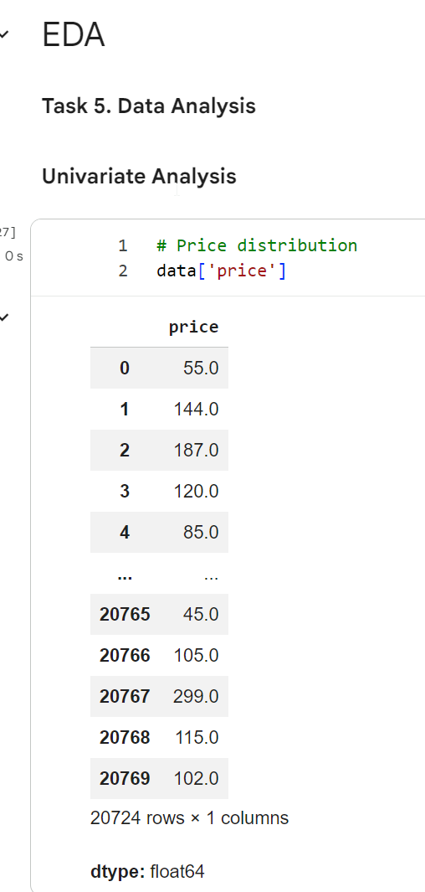

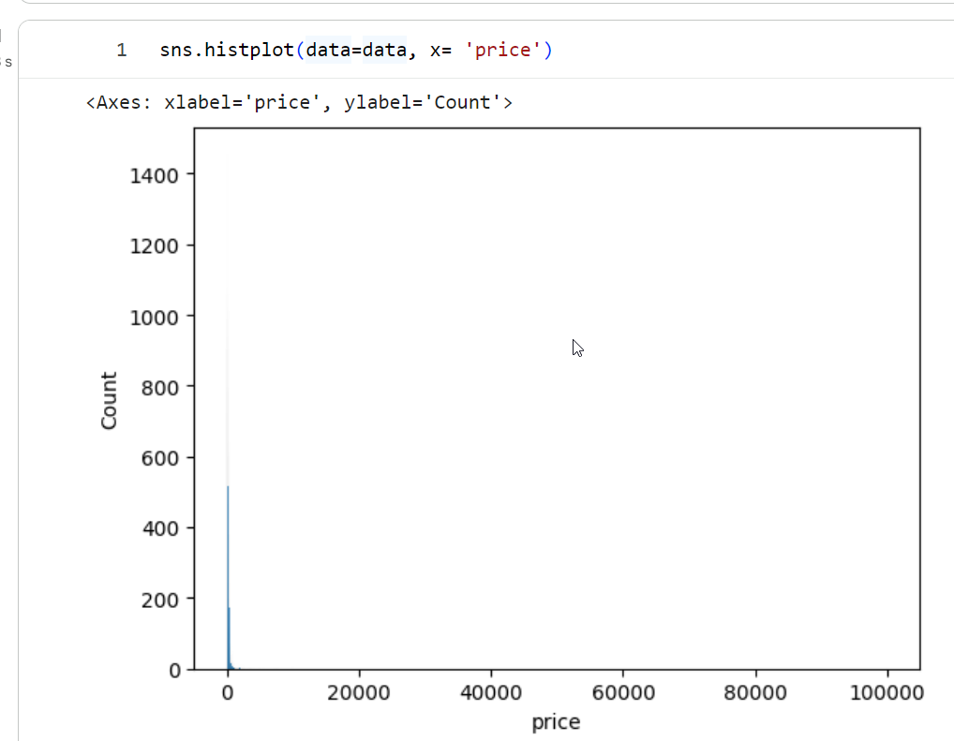

Created a histogram using Seaborn (sns.histplot) to visualize the distribution of the price column. The resulting plot shows a heavily right-skewed distribution, indicating that the majority of prices are concentrated near lower values while a few extreme high-value outliers push the x-axis scale up to 100,000.
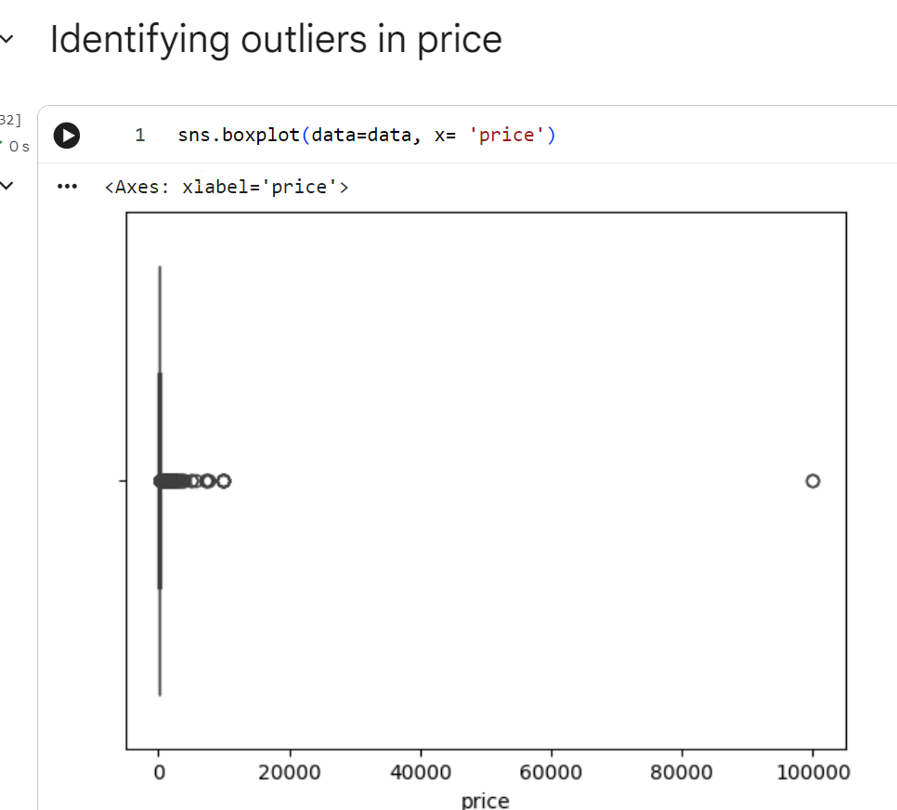
Generated a box plot using Seaborn (sns.boxplot) to identify outliers in the price column. The visualization shows that the bulk of price values are compressed near 0, with several distinct extreme outliers—most notably a major outlier around 100,000—confirming heavy skewness in the dataset.

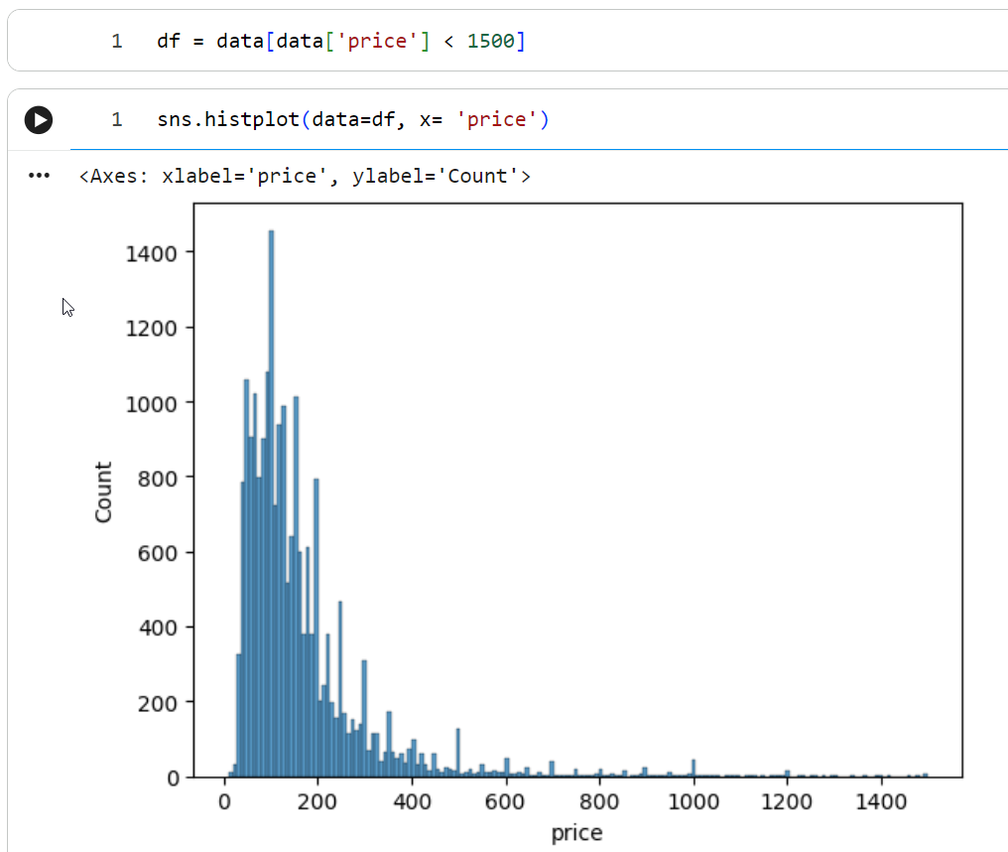
Outlier Identification & Filtering (price)
- Identifying Outliers (sns.boxplot): I generated a box plot to check the distribution and identify extreme values in the price column. The plot shows that almost all listings are squished near zero, with extreme outliers reaching up to 100,000, which distorts the scale and analysis.
- Filtering Outliers (df = data[data['price'] < 1500]): To remove these extreme values, I filtered the dataset to keep only listings with prices below 1,500.
- Visualizing the Cleaned Distribution (sns.histplot): After filtering out the outliers, I created a new histogram using data=df. The resulting plot clearly displays a realistic, right-skewed price distribution, with most prices concentrated between 50 and 300.

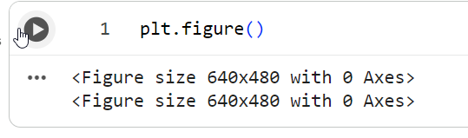

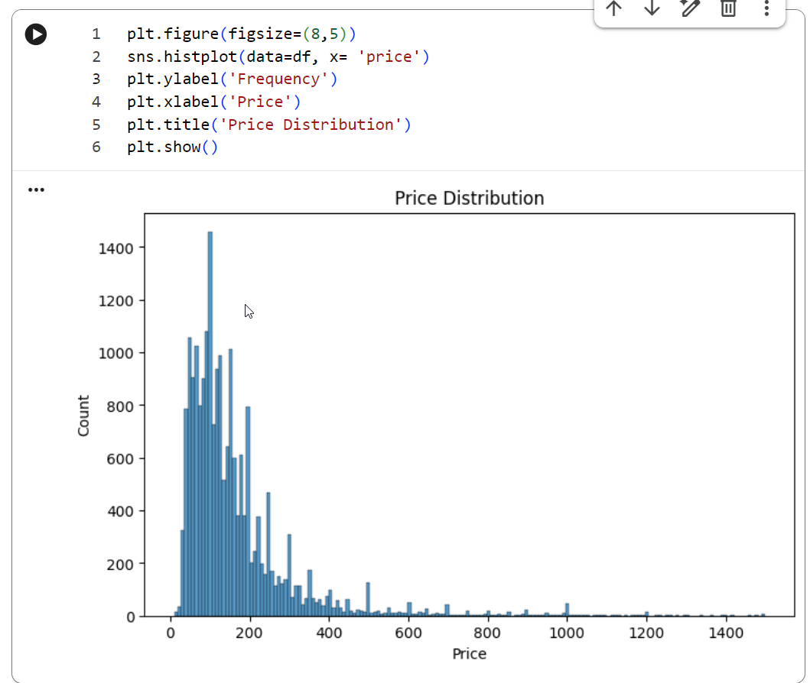
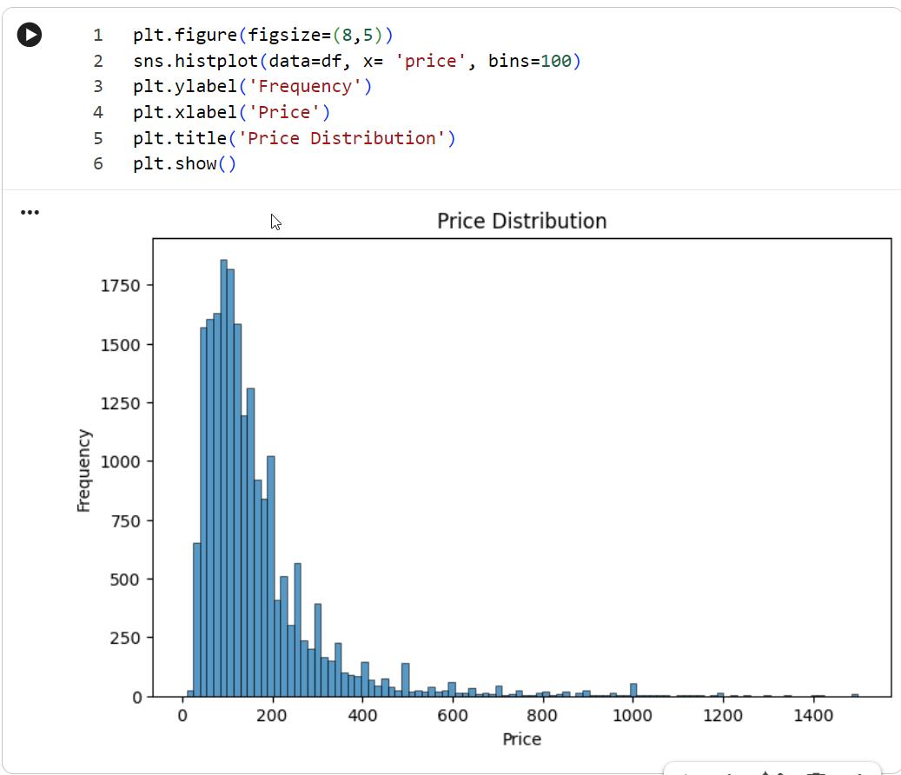
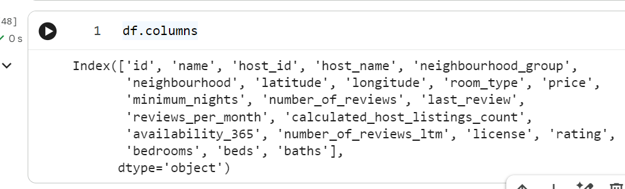

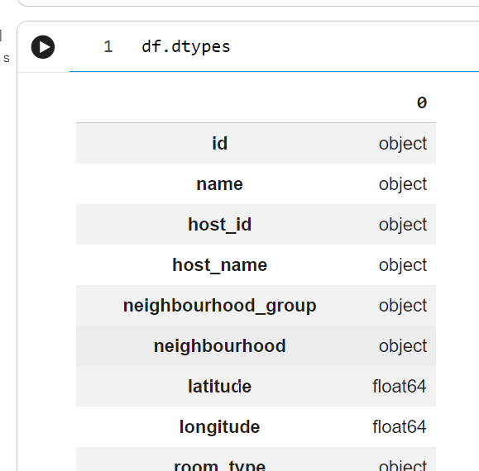

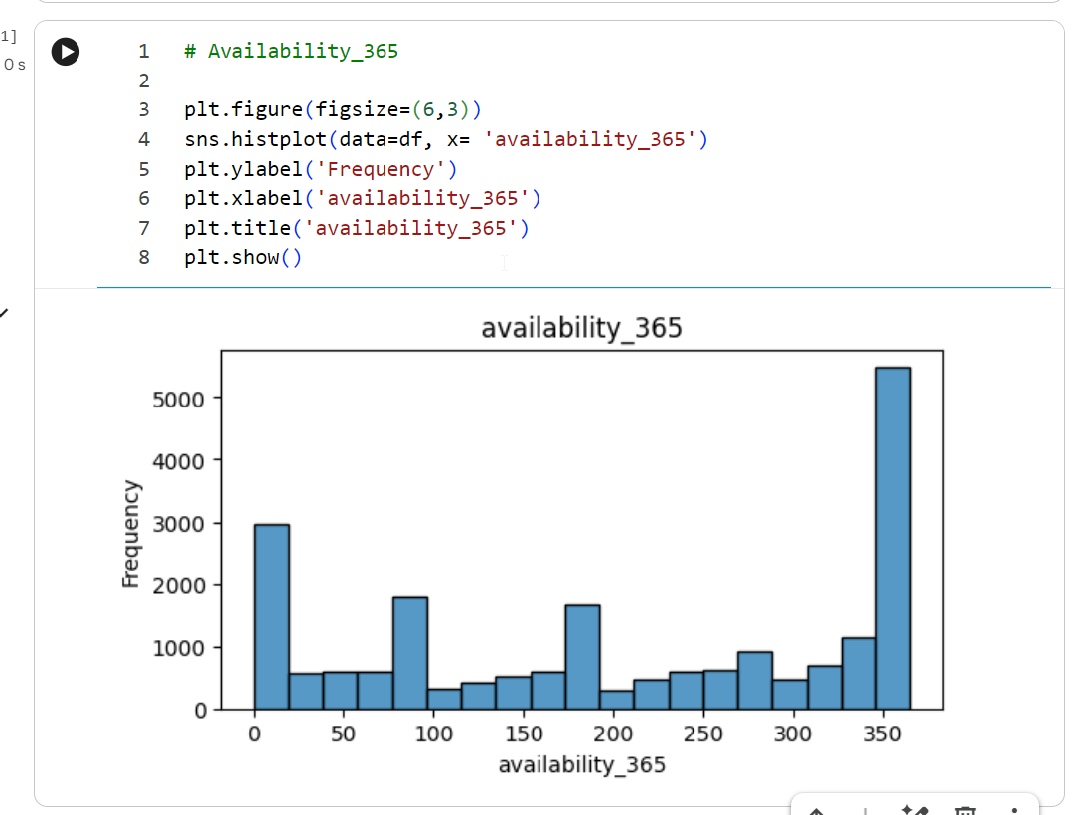

“Created a histogram using Seaborn (sns.histplot) with 100 bins to visualize the distribution of the availability_365 column. The resulting plot shows two major peaks: one at 0 days (listings unavailable all year) and a significant spike at 365 days (listings available year-round), with smaller clusters around common seasonal intervals like 90 and 180 days. “

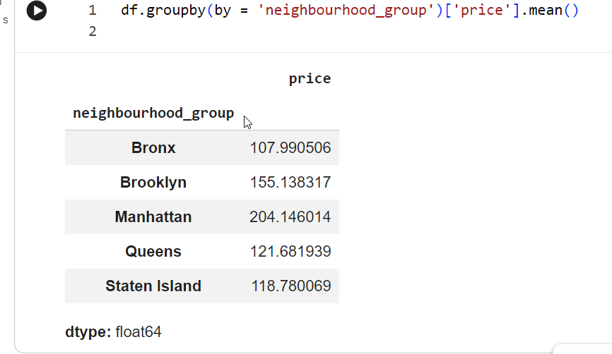
“Calculated the average price per neighbourhood group using df.groupby(by='neighbourhood_group')['price'].mean(). The output shows that Manhattan has the highest average listing price (~$204.15), followed by Brooklyn (~$155.14), while the Bronx holds the lowest average price (~$107.99). “

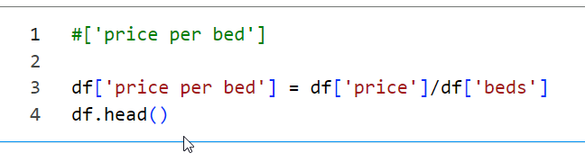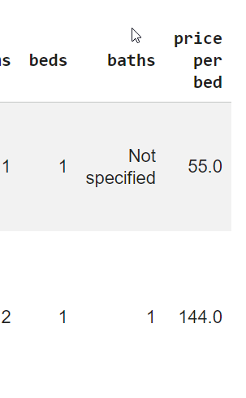
“Created a new feature called price per bed by dividing the total listing price (df['price']) by the number of beds (df['beds']). This allows for a more standardized comparison of pricing efficiency across properties with different guest capacities. Displayed the updated DataFrame using df.head(). “

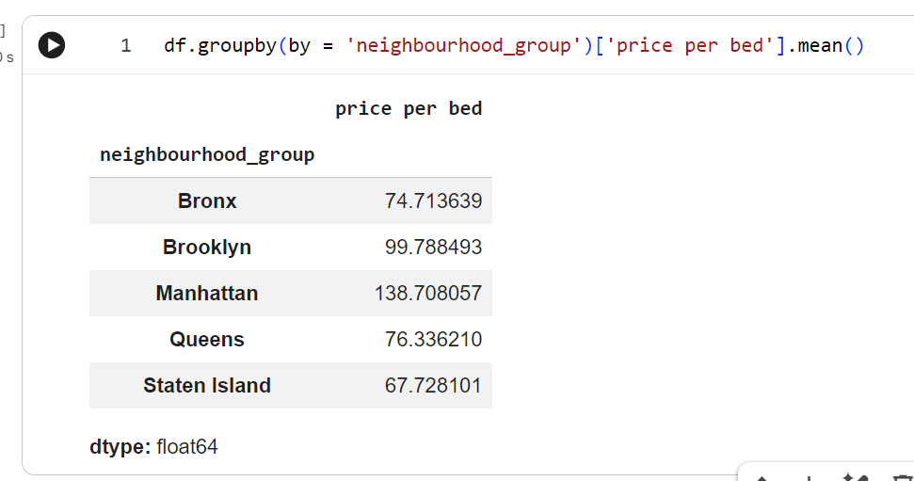

“Calculated the average price per bed across each neighbourhood group using df.groupby(by='neighbourhood_group')['price per bed'].mean(). The results show that Manhattan has the highest average cost per bed (~$138.71), followed by Brooklyn (~$99.79), while Staten Island (~$67.73) offers the lowest average cost per bed. ”

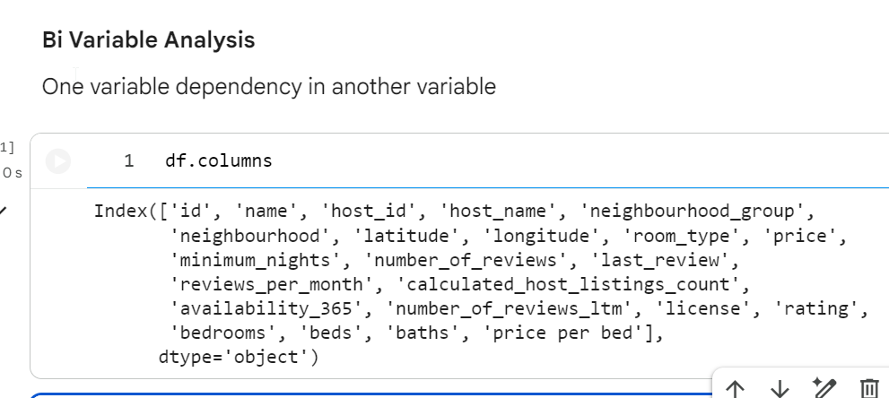

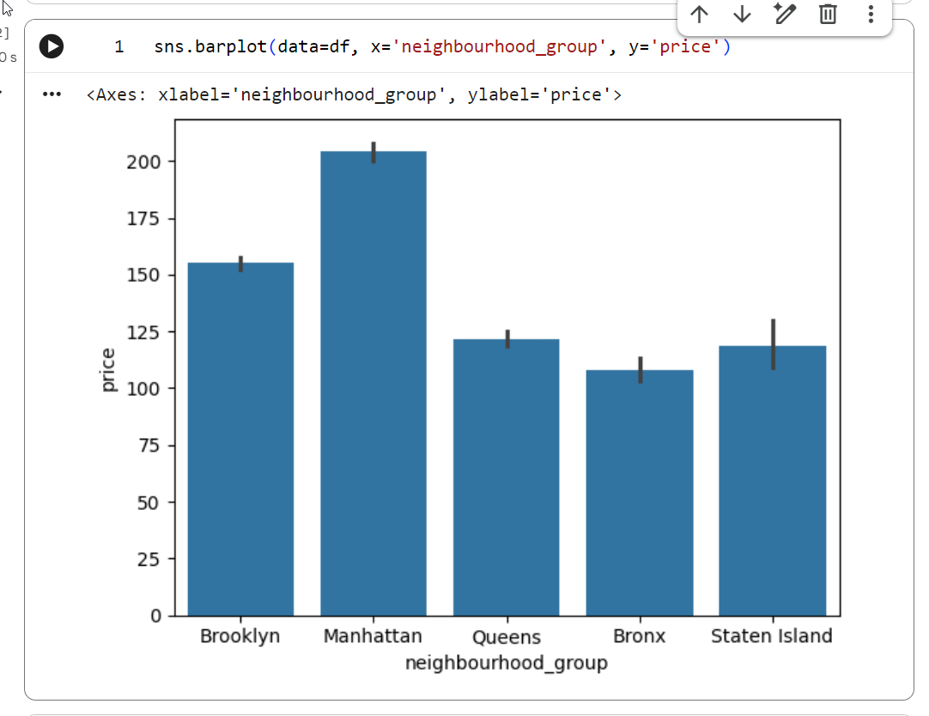

“Created a bar plot using Seaborn (sns.barplot) to visualize the average listing price across each neighbourhood_group. The plot highlights Manhattan as having the highest average price, followed by Brooklyn, while Queens, Staten Island, and the Bronx show lower average prices. The black error bars represent the confidence intervals for each group's mean price. “

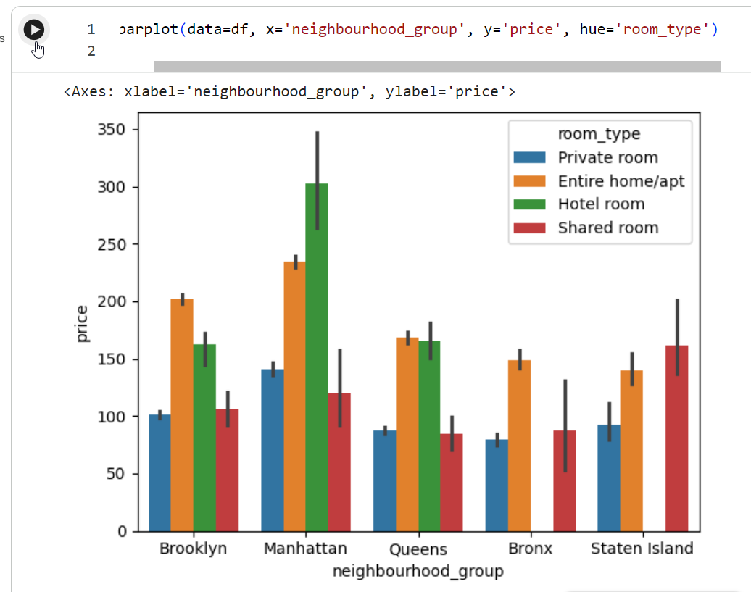

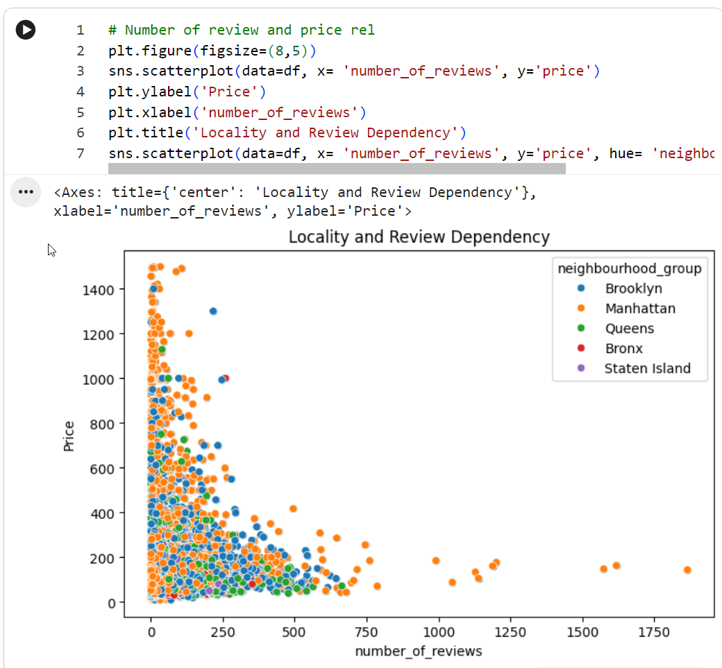

“Generated a scatter plot using Seaborn (sns.scatterplot) to explore the relationship between number_of_reviews and price, color-coded by neighbourhood_group.
Key Insights:
- Inverse Relationship: Listings with very high numbers of reviews (e.g., above 500) tend to have lower prices (mostly under $200), suggesting that lower-priced listings attract higher booking volumes and collect more reviews.
- High-Price Concentration: The highest prices ($800–$1500) occur almost exclusively among listings with fewer than 250 reviews, primarily located in Manhattan (orange) and Brooklyn (blue).”
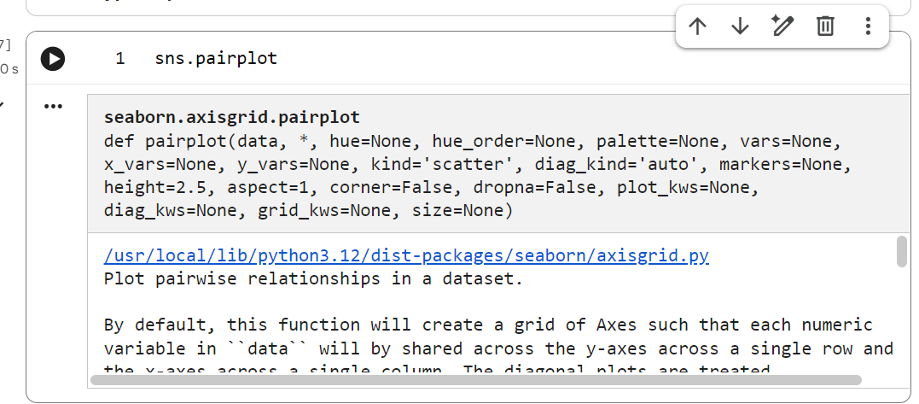

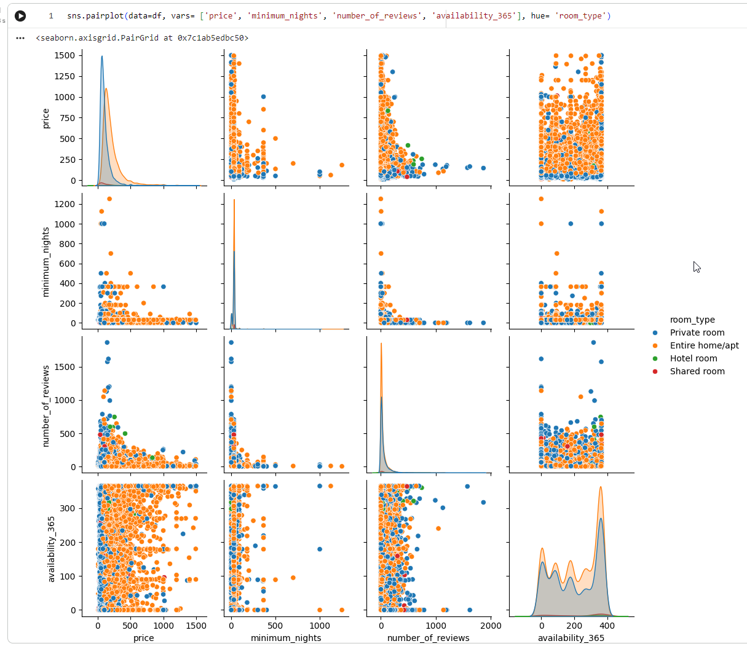
“Distributions (Diagonal): Most numerical variables (price, minimum_nights, number_of_reviews) display strongly right-skewed distributions across all room types, whereas availability_365 shows a bimodal distribution with heavy concentration near 0 and 365 days.
Pricing Patterns: Entire homes/apartments (orange) consistently span higher price points across all scatter plots compared to private rooms (blue).
Reviews vs. Minimum Nights: Listings with extremely high minimum stay requirements or exceptionally high review counts are almost exclusively clustered at lower price points.
”
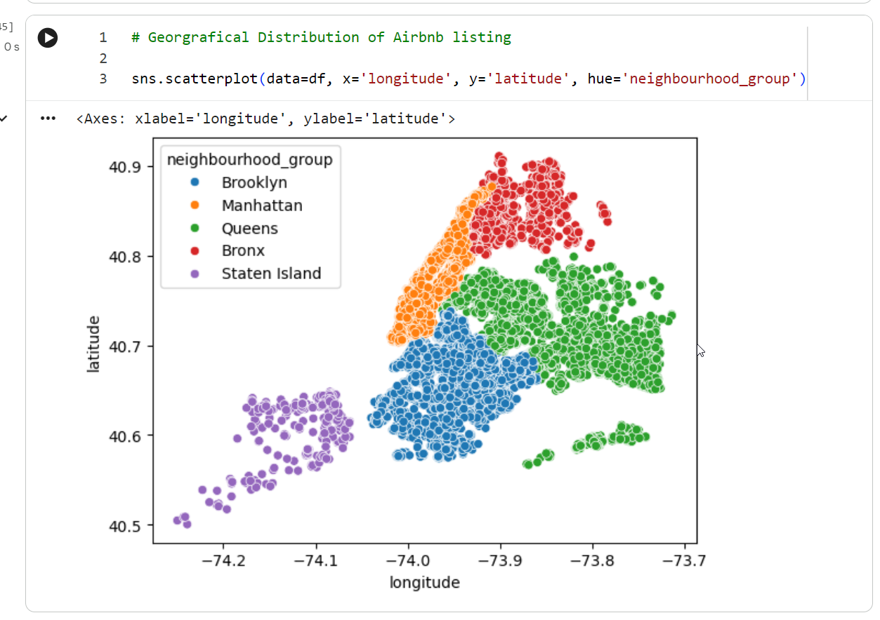
“Geographic Map Outline: By plotting coordinates directly, the scatter plot visually mirrors the actual geographic map of New York City's five boroughs.
Density & Clustering: Manhattan (orange) and Brooklyn (blue) display the highest density of listings, forming tight, heavily populated clusters. Queens (green) spans a wider area with moderate density, while Staten Island (purple) and the Bronx (red) show more sparse, spread-out listing distributions.”

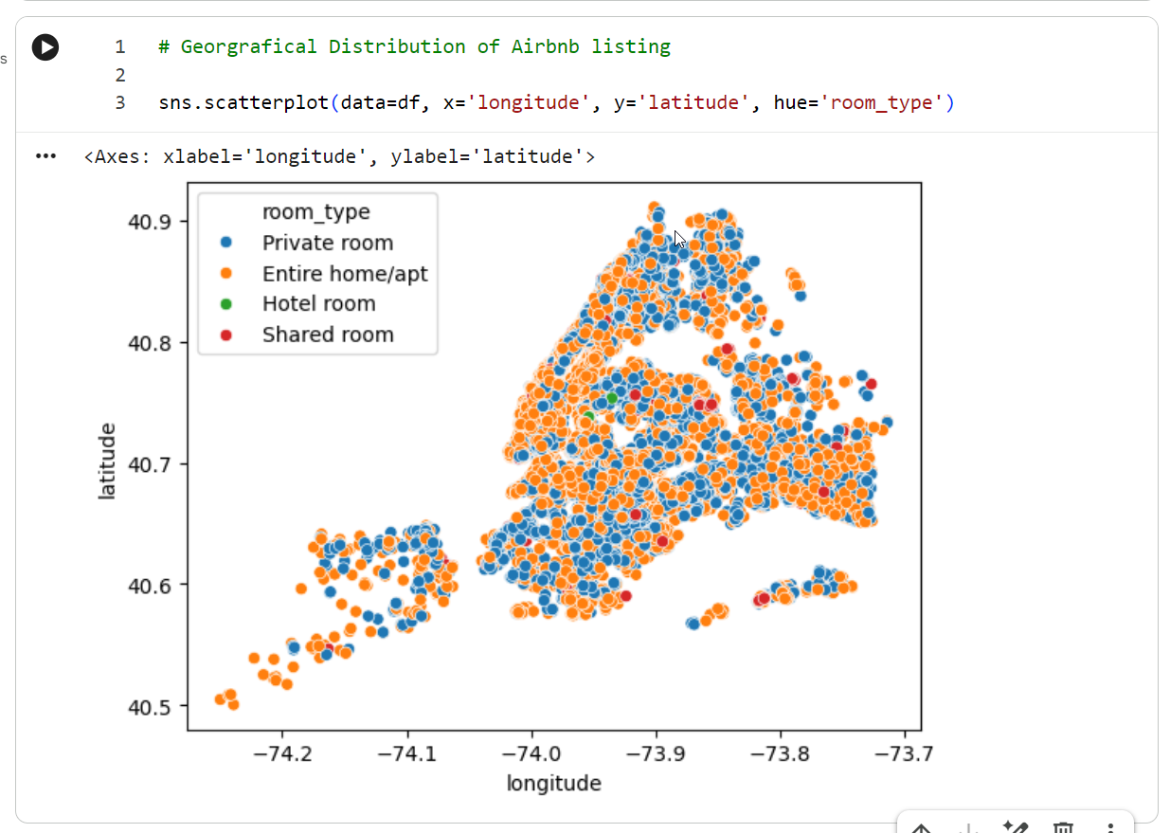
“Dominant Categories: Entire home/apt (orange) and Private room (blue) make up the vast majority of listings and are heavily dispersed across the entire geographic region.
Density Concentration: Entire home/apt listings show higher density in central areas like Manhattan, whereas Private room listings are broadly distributed throughout outer areas such as Brooklyn and Queens.
Minority Categories: Hotel room (green) and Shared room (red) represent a negligible fraction of the total listings, appearing as isolated, sparse points on the map.”
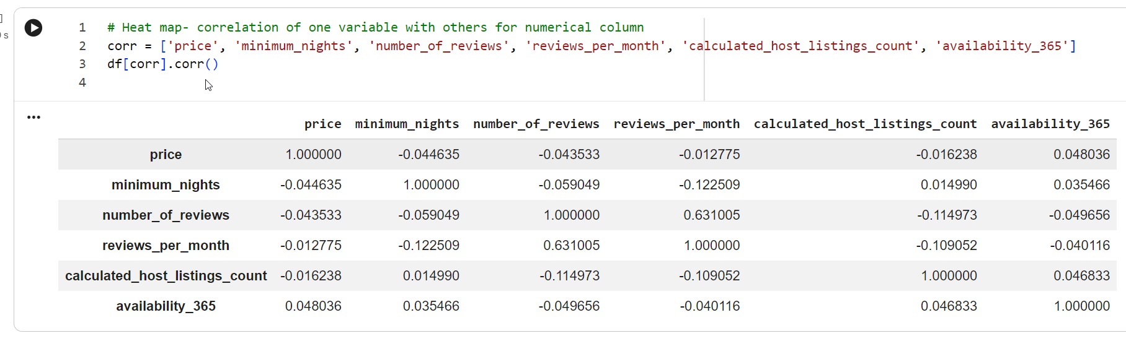
“Strong Correlation: A moderate-to-strong positive linear relationship exists between number_of_reviews and reviews_per_month (~0.63), as expected.
Weak/No Correlation: The price column shows almost no linear correlation with any other numerical feature, with all coefficients remaining close to zero (ranging between -0.045 and 0.048).
Overall Independence: Most other numerical features display very weak negative or positive correlations with each other (values stay close to 0), suggesting minimal linear dependency across numerical attributes.
”
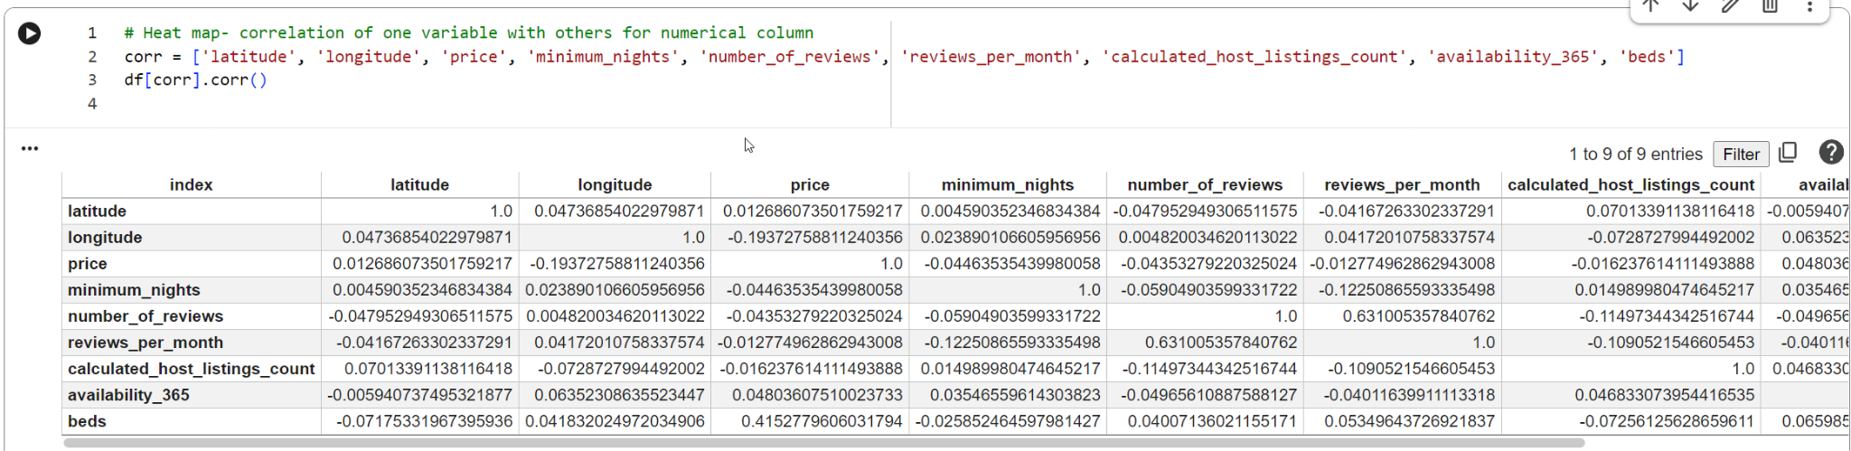
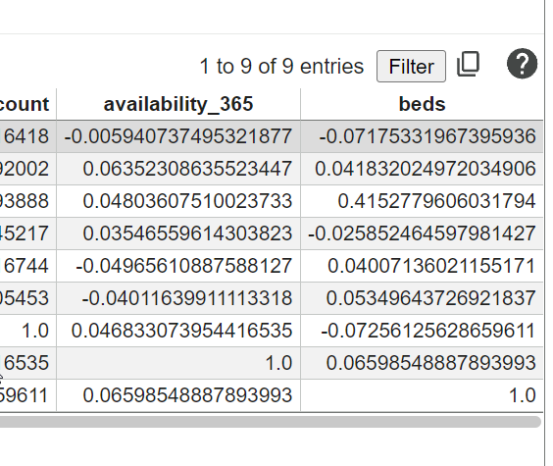
“Price vs. Beds Correlation: A moderate positive correlation exists between price and beds (~0.415), making beds the strongest linear predictor of price among all numerical features.
Geographic Price Skew: price has a slight negative correlation with longitude (~-0.194), reflecting higher average listing prices moving westward (toward Manhattan).
Review Activity: number_of_reviews and reviews_per_month maintain a strong positive correlation (~0.631) as expected.
General Independence: Most other numerical variables display weak correlations with each other, remaining near zero.”
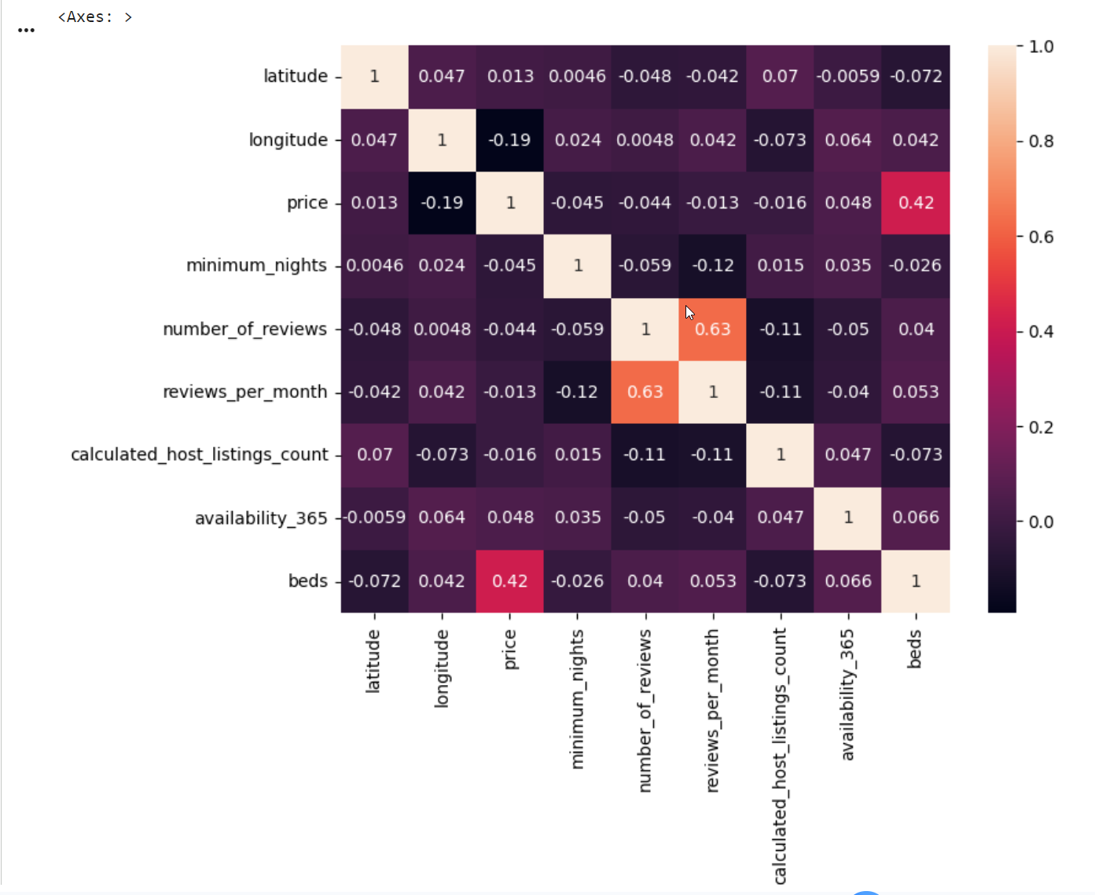
“Strongest Positive Correlation (Reviews): number_of_reviews and reviews_per_month show a distinct orange highlight with a correlation coefficient of 0.63, indicating a strong linear relationship as expected.
Price Drivers (Beds): price and beds show a moderate positive correlation of 0.42 (highlighted in reddish-pink), confirming that the number of beds is the main numerical driver of listing price.
Geographic Price Relationship: price and longitude show a mild negative correlation of -0.19 (darker square), reflecting higher prices further west toward Manhattan.
Independence Across Features: Most other variable pairs show coefficients close to zero (ranging from -0.12 to 0.07), depicted in dark purple tones, indicating little to no linear relationship.”

